**University of Petroleum and Energy Studies**

School of Computer Science

Department of Cybernetics

**Graphics & Animation Tools**

**LAB FILE**

**(Session: 2020-2021)**

Course: B. Tech with Specialization in Open Source and Open Standards

Submitted To- Submitted By-

Dr. Durgansh Sharma Kunal Ojha

Associate Professor SAP ID -500063333

Department of Cybernetics Roll No. -R100217034

**Experiment 7-** Design of 3D Rocket using Blender

Google Drive Link- <https://drive.google.com/drive/folders/1JxNBRRfg-df1dwClwkPAdpHcAu0AWqI3?usp=sharing>

Step 1- Open blender and select new file type as general

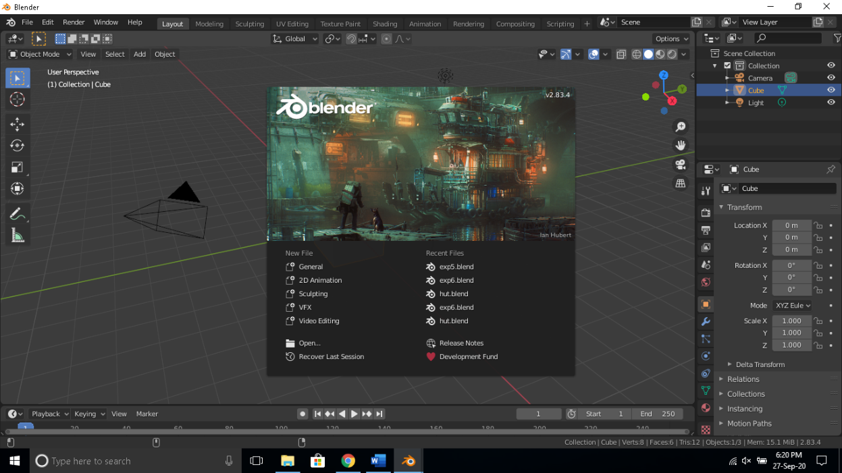

Step 2-In layout mode click on add select mesh and click on cylinder adjust the size of cylinder using scale tool and go to modelling tab and add loop cuts so that you can shape the cylinder into the body of a rocket.

Step 3- Use the bevel tool in modelling to model the cylinder into the following shape

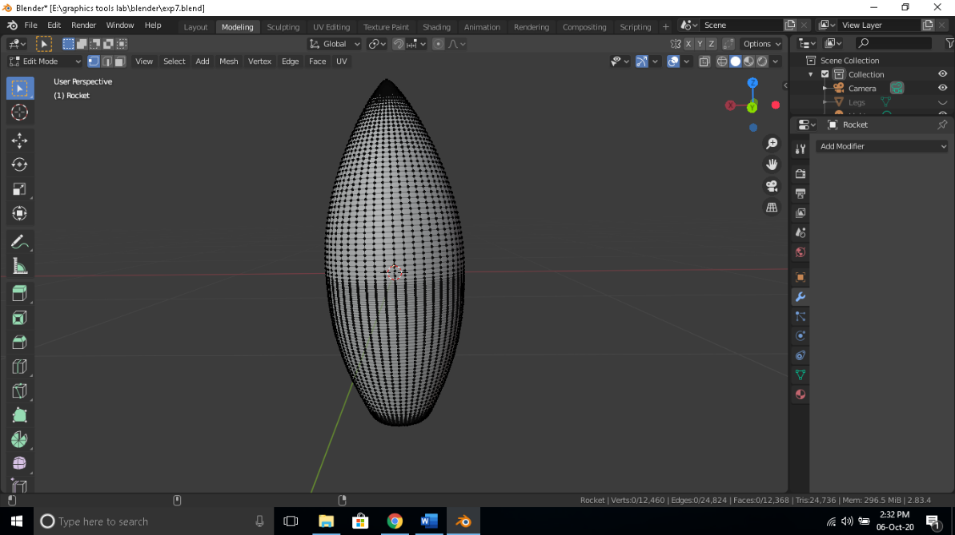

Step 4- Add another cylinder on the side of the main body and bevel it to make it look like a window as shown below.

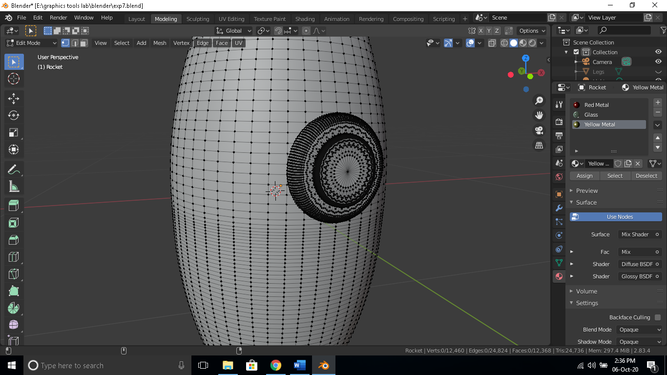

Step 5- Now add 4 cones on the bottom of the main body and reshape them using loop cuts and bevel and use the move tool to arrange it as shown below.

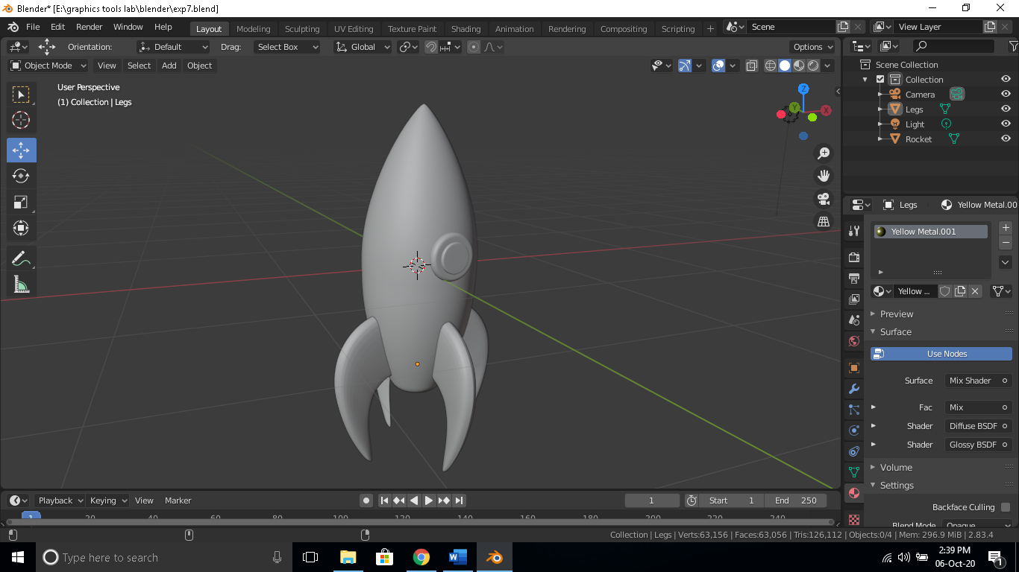

Step 6- Apply color to each surface as suitable and render the output image.

